## horizontal line



Squirrel Squad

Project 2: Group 3 Team Members:

* Sherin Mattappallil
* Zachary Kopec
* Bill Roll
* Rachel Chan
* Kinnari Patel

# Overview

* When we think of potential harm in New York City, we primarily think of other people and manmade objects. However, there is a variation of wildlife that also resides there as well. Looking at Central Park, specifically, several species of mammals, birds, and reptiles that also call the city their home. The members in our group are interested in one such mammal, the squirrel. Our project aims to take information gathered on the squirrels of Central Park and display the data meaningfully to help keep natives, visitors, and the squirrels safe . Factors such as geological location, age, and behavior will all determine the outcomes of our visualizations as we look to inform the public with our data.
* **Why are our visualizations relevant?** 
  + Squirrel behavior linked to public safety and health.
  + Squirrels can carry rabies, lyme disease etc. Squirrel attacks are also common in NYC, so there is a health risk.
  + News Link- <https://nypost.com/2019/03/22/animal-lovers-rip-proposed-ban-on-feeding-pigeons-and-squirrels/>

# Goals

* Query data using API URL.
* Plotting behavior data of squirrels in different areas of central park.
* Plotting the density of squirrels in different areas of Central Park.
* Visualizations will include scatterplot, heatmap etc (listed below).

# Specifications

### Our data set is made up of the geological locations of the various squirrels found in Central Park as well as some additional recorded attributes:

* Primary fur color
* Age
* The time of day the squirrel was spotted (AM/PM)
* The interaction the squirrel had with the recorder
* The activity the squirrel was in the middle of when spotted by the recorder

**Desired visualization types**

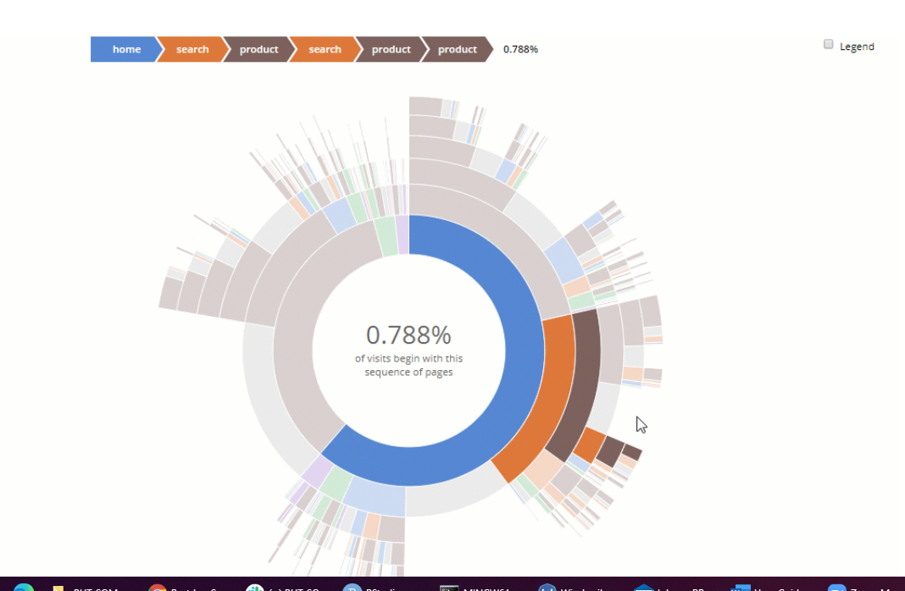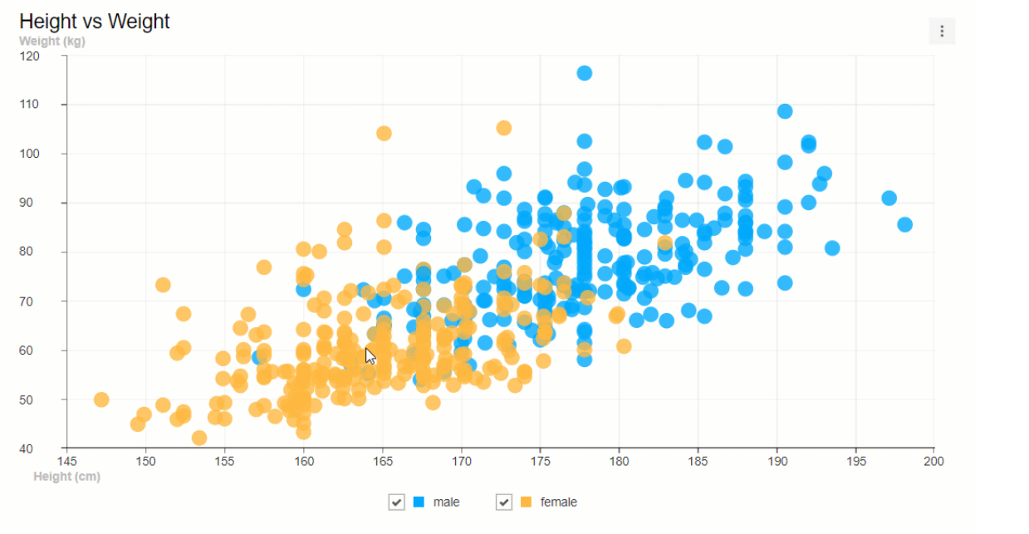

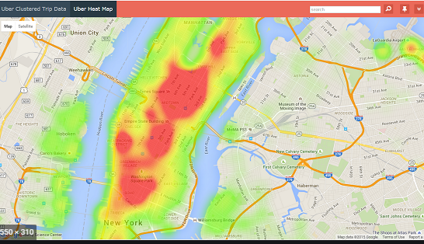

**Sources**

* 2018 Squirrel Census Fur Color Map
  + <https://data.cityofnewyork.us/Environment/2018-Squirrel-Census-Fur-Color-Map/fak5-wcft>
  + The Squirrel Census (<https://www.thesquirrelcensus.com/>) is a multimedia science, design, and storytelling project focusing on the Eastern gray (Sciurus carolinensis). They count squirrels and present their findings to the public. This table has squirrel data for each of the 3,023 sightings. It includes age, location coordinates, primary and secondary fur color, elevation, activities, communications, and interactions between squirrels and with humans.

# Milestones

* A link to the primary GitHub repository you’ll be housing your work in:
  + <https://github.com/WilliamRoll/Project-2>
  + Complete proposal